Linux Basic Commands – Assignment Submission
1. Creating and Renaming Files/Directories
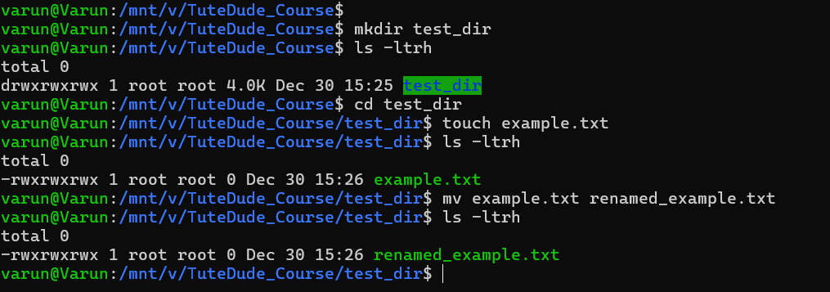
Commands Used
mkdir test_dir
cd test_dir
touch example.txt
mv example.txt renamed_example.txt
Explanation
The mkdir command is used to create a new directory named test_dir.
After entering the directory, the touch command creates an empty file called example.txt.
The mv command is then used to rename example.txt to renamed_example.txt.
The mv command is commonly used for both moving and renaming files in Linux.

2. Viewing File Contents
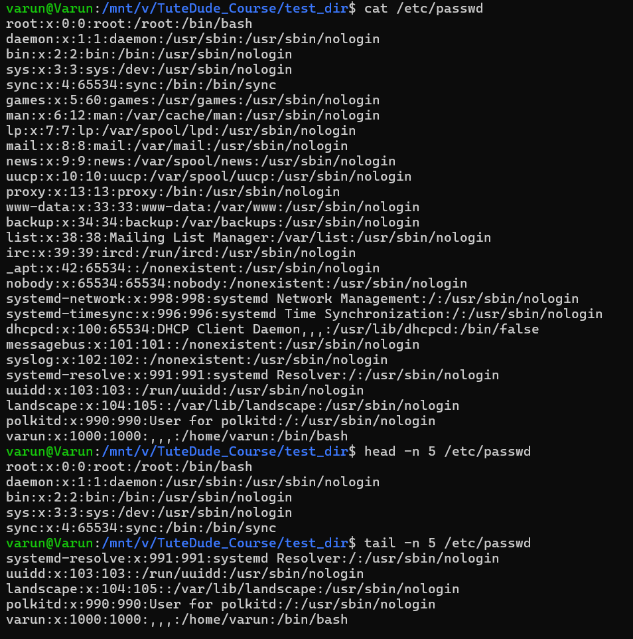
Commands Used
cat /etc/passwd
head -n 5 /etc/passwd
tail -n 5 /etc/passwd
Explanation
The /etc/passwd file stores information about system users.
The cat command displays the complete contents of the file.
The head command shows the first 5 lines of the file, which is useful for quickly viewing the beginning.
The tail command displays the last 5 lines, useful for checking recent or ending entries.

3. Searching for Patterns
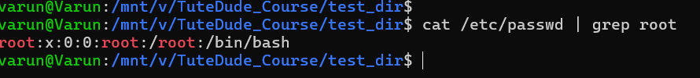
Command Used
cat /etc/passwd | grep root
Explanation
The grep command is used to search for specific patterns in text.
In this case, it searches for all lines containing the word root in the /etc/passwd file.
The pipe (|) passes the output of cat as input to grep.
4. Zipping and Unzipping Files
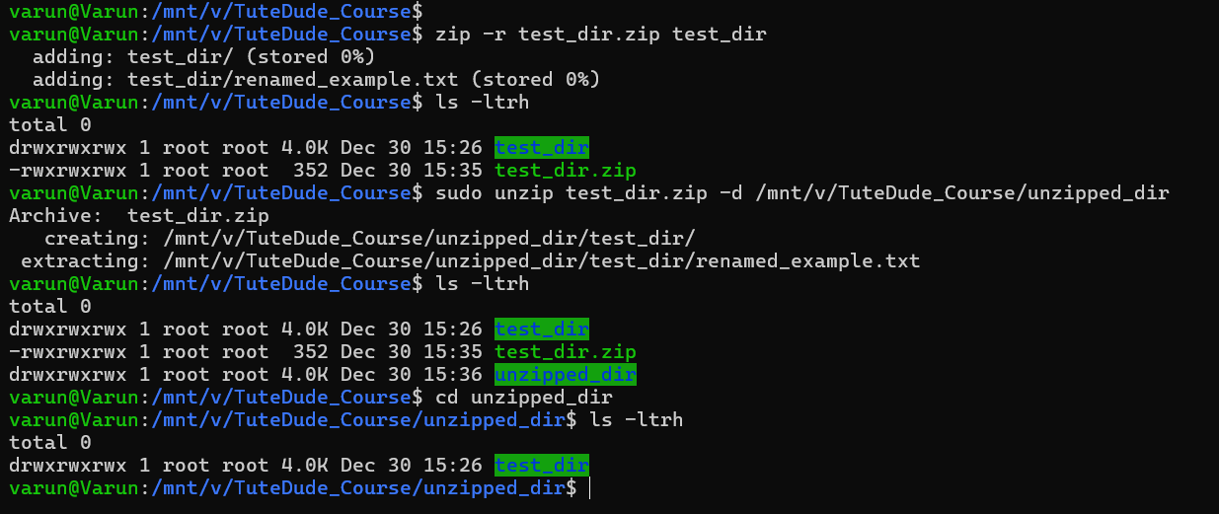
Commands Used
zip -r test_dir.zip test_dir
unzip test_dir.zip -d unzipped_dir
Explanation
The zip -r command compresses the directory test_dir recursively into a file named test_dir.zip.
The unzip command extracts the contents of the zip file into a new directory called unzipped_dir.
This is commonly used for backups and file transfers.

5. Downloading Files Using wget
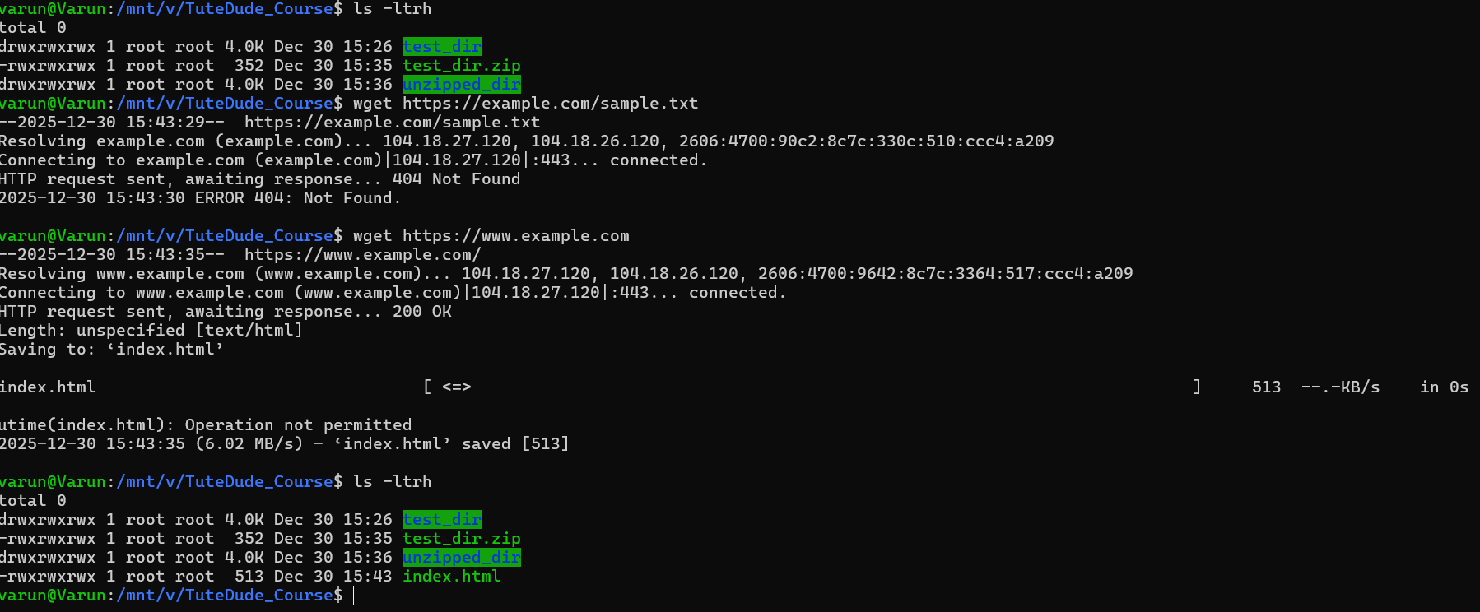
Command Used
wget https://www.example.com
Explanation
The wget command is used to download files from the internet using a URL.
In this case, it downloads the HTML content of example.com and saves it as index.html in the current directory.
6. Changing File Permissions
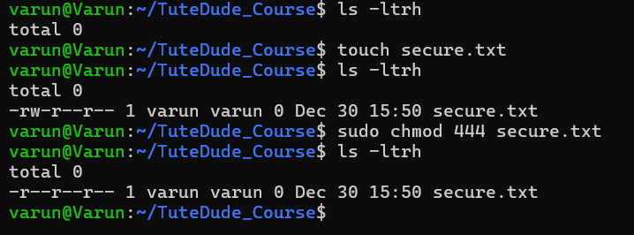
Commands Used
touch secure.txt
chmod 444 secure.txt
Explanation
The touch command creates a file named secure.txt.
The chmod 444 command changes the file permissions to read-only for the owner, group, and others.
This means no user can modify or execute the file, ensuring data protection.
7. Working with Environment Variables
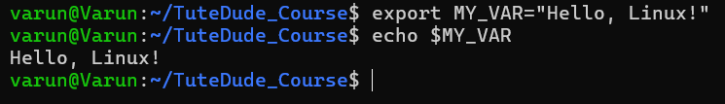
Commands Used
export MY_VAR="Hello, Linux!"
echo $MY_VAR
Explanation
The export command creates an environment variable named MY_VAR with the value "Hello, Linux!".
The echo command is used to display the value of the environment variable.
Environment variables are commonly used to store configuration values in Linux.

